|  |  |  |
| --- | --- | --- |
| Author’s name  Ali Sadreddini  Raja Ravi  Scott Howell  Tammy Chan | Sub-business unit  LoT DevOps | Issue number  0.60 |
| Business unit  IoT | Issue date  4 April 2019 | Telstra ID  AAAIU-2035432041-1566 |

Detailed Design

-

Location of Things LTE Tag Launch

## Table of Contents

Table of Contents 2

1 Scope and purpose 3

2 Program and Product at a glance 3

2.1 Architecture at a glance 3

3 Stakeholders 4

4 LTE Device Specifications 4

4.1 Device Parameters 4

4.2 Profile Parameters 6

4.3 Device Control parameters set by MQTT 7

4.4 Modes of Operation 8

4.4.1 Normal Operation 9

4.4.2 OTA Upgrade Mode Conditions 9

4.5 Authentication and Security 9

4.5.1 Device Authentication 9

4.5.2 Data integrity 10

4.6 LTE Telemetry data, Firmware upgrades and Setting the device control parameters 11

4.6.1 Telemetry Data flow 11

4.6.2 Message processing in the tag 11

4.6.3 Device Registration 13

4.7 LED Behaviour 14

4.8 Button Behaviour 14

4.8.1 Tracker in Shipping State 14

4.9 Buzzer Behaviour 15

4.10 Battery Level Reporting 15

5 Integration specifications 15

5.1 LTE Device from or to LoT app 15

5.2 LTE Device to IoT Hub 16

5.2.1 All MQTT transaction Payloads 17

6 References and Attachments 23

7 DOCUMENT CONTROL SHEET 23

8 Record of changes 23

9 APPENDIX – A 24

9.1 LoT App Expectations to support the Device design 24

9.2 LoT platform Expectations to support the Device design 24

9.2.1 IoT Hub 24

9.2.2 Microservice (Service Fabric) 24

9.3 Azure PaaS cloud References 24

# Scope and purpose

The scope of the document is to provide the detailed design details to the DEVOPS team and the manufacturer teams in designing the respective components involved in the solution for enabling the LTE tags. This is for both consumer and enterprise customers.

The purpose of the document is to ensure that the teams agree on the design and document the evolving phase outcomes to ensure the expectations are rightly set with the other stakeholders e.g. testers, product managers et all.

# Program and Product at a glance

Telstra is introducing a new location service into the market which is a subscription based finding service to help the customer track their things that matter most to them – from keys, bags to bikes, pets and business assets like tools and vehicles. It works by attaching a ‘Telstra Locator’ or ‘Tracking & Monitor’ tag to their valuables and the customers using the Locator Mobile app compatible to iOS and Android smart phones and tables. The tag will use different technologies and Telstra networks to help customer find their things. One of such tag technologies is LTE based one while the other two are Bluetooth (implemented in phase1) and Hybrid Wi-Fi (Wi-Fi and Bluetooth) implemented in phase 2. The phase 1 and 2 are expecting to be launched very soon (at the time of drafting the first version of this document).

This document is about phase 3 of the project to enable the LTE Tag into the market. The LTE Tag is also hybrid in nature with Bluetooth enablement.

## Architecture at a glance

The key objective of the program is to provide location based service to Telstra customers to address customers’ needs on loss prevention, loss recovery and asset tracking based on Bluetooth, Wi-Fi and LTE devices, Telstra 24*7 and LoT mobile applications, and Telstra Air home gateways.

The LoT solution is utilising a number of new Azure services including Azure Notification Hub, Azure Event Hub, Azure IoT Hub, Azure Application Insight, Azure Service Fabric and Azure Service Environment deployed in Telstra External Azure tenancy and most of aforementioned Azure services have not previously been certified by Telstra.

The solution is also integrated with a number of existing on-premise Telstra systems including DDC, RNMS, TDI, MSP and COAP, as well as SaaS services Pagerduty and Flex from other vendors.

# 

Figure 1: Scope of the Risk Assessment –high level view context diagram

As indicated in the diagram above, the LoT solution includes a very broad range of Azure Services and integration into existing Telstra systems.

The diagram above provides a simplified view of the LoT solution and the context of the security risks assessed.

# Stakeholders

|  |  |  |
| --- | --- | --- |
| Stakeholder Name | Designation | Project Role |
| Scott Howell | Product Senior Specialist | Product Owner – Devices |
| Michael Yang | Product Specialist | SME - Devices |
| Fiona Hanson | Location – Senior Engineer | Program Lead |
| Jason Bird | IoT Devops – Senior Lead | DevOPs manager and Tech. Manager |
| Inseego Team | The LTE tag vendor team |  |
| Ali Sadreddini | IoT Devops – Software Senior Engineer | DevOps team rep. |
| Paul Hamshere | Product Principal | IoT Devices and Platform |
| Lauren Demarchi | Project – Senior Lead | Enterprise BA |
| Tammy Chan | Requirements Gathering – Senior Specialist | Program Business Analyst |
| Atif Saleem | Project Manager | Project Manager |
| Arpit Jain | Network – Senior Engineer | Test Lead |
| Glen Schofield | Systems – Senior Engineer |  |
| Raja Sekhar Ravi | Senior Solutions Architect | Lead architect |

# LTE Device Specifications

The device design level details are explained in the following sections.

## Device Parameters

|  |  |  |
| --- | --- | --- |
| Feature | Consumer | Enterprise |
| Electrical |  |  |
| BLE Radio | Yes | Yes |
| *Power Level* | 5dBm | 5dBm |
| *Version* | 4.2 | 4.2 |
| *Chipset* | ST BLUENRGCSP | ST BLUENRGCSP |
| Wi-Fi Radio | Yes | Yes |
| *Power Level* | 15dBm | 15dBm |
| *2.4Ghz Frequency* | Yes | Yes |
| *5Ghz Frequency* | - | - |
| *Chipset* | Espressif - ESP8266 | Espressif - ESP8266 |
| LTE Radio | Yes | Yes |
| *Cat-M1* | Yes | Yes |
| *Cat-NB1* | - | No |
| *Chipset* | Sequans Monarch GM01G | Sequans Monarch GM01G |
| *SIM* | 4FF | 4FF |
| IMEI Prefix for TAC | TBC | TBC |
| Location Service | BLE via Listening Network, GPS, A-GPS | BLE via Listening Network, GPS, A-GPS |
| Battery | Rechargeable Lithium | Replaceable |
| Buzzer | 15mm Piezo | 15mm Piezo |
| Button | Yes | Yes |
| LED | Yes (multi-colour) | Yes (multi-colour) |
| Power Interface | USB Type-C | - |
| Sensors |  |  |
| 3-Axis Accelerometer | Yes | Yes |
| Gyroscope | Yes | Yes |
| Temperature | - | Provision for future support |
| Pressure | - | Provision for future support |
| Humidity | - | Provision for future support |
| Power |  |  |
| Source | Battery | Battery |
| Detail | Rechargeable Lithium | Non-Replaceable |
| Battery Type | 1000mAh LiPo | 3 x Lithium AA |
| Battery Life | 10~12 weeks | Up to 5 years |
| Shelf Life | 6 months | TBC |
| Physical |  |  |
| Dimensions (L x W x D) | 75 x 35 x 19 mm | 86 x 60 x 31 mm |
| Weight | TBC | TBC |
| RF Range | >60m | >60m |
| Buzzer Sound Level | 85 Db | 85 Db |
| IP Rating | IP67 | IP68 |
| Vents | - | Yes, for humidity |
| Certifications / Compliance |  |  |
| ROHS compliance | Required | Required |
| RCM | Required | Required |
| CE | Required | Required |
| Bluetooth SIG | Required | Required |
| Telstra Mobile Network | Required | Required |
| Functionality |  |  |
| Tag buzzer / Locate my Tag | Device tone triggered by mobile app | Device tone triggered by mobile app |
| Polling / Reporting /Advertising | BLE and LTE | BLE and LTE |
| OTA Update | Via CAT-M1 using MQTT | Via CAT-M1 using MQTT |
| Package Contents – Items | CAT-M1 Tag  USB charging cable  Loop for Eyelet | CAT-M1 Tracker  VHB Tape  Metal Zip Tie  Mounting Plate |

## Profile Parameters

|  |  |  |  |  |
| --- | --- | --- | --- | --- |
|  | Consumer & Small Business | | Enterprise | |
| Product | **Bartlett** | | **Stone** | |
| Device Name | **Locator Tag – CAT-M1** | | **Rugged CAT-M1 Tracker** | |
| Detailed Profile Specs | **Factory - OOB** | **MVP1** | **Factory - OOB** | **MVP1** |
| Firmware Version Required | TBD | TBD | TBD | TBD |
| Profile Specifics | | | | |
| BLE Radio | Enabled | Enabled | Enabled | Enabled |
| Advertising / Polling Rate | 2570ms | 2570ms | 2570ms | 2570ms |
| Burst Advertising Rate (first 30 secs) | 546.25ms | 546.25ms | 546.25ms | 546.25ms |
| Burst Advertising Rate (further 30 secs) | 1285ms | 1285ms | 1285ms | 1285ms |
| Duty Cycle | 100% | 100% | 100% | 100% |
| Wi-Fi Radio | Disabled | Disabled | Disabled | Disabled |
| Home AP/Safe Zone Scan | - | - | - | - |
| LTE Radio | Enabled | Enabled | Enabled | Enabled |
| Cat-M1 | Yes | Yes | Yes | Yes |
| Cat-NB1 | Available  (future support) | Available  (future support) | Available  (future support) | Available  (future support) |
| Location Based Services | Priority Order | Priority Order | Priority Order | Priority Order |
| Bluetooth | 1st | 1st | 1st | 1st |
| Wi-Fi Geolocation | - | - | - | - |
| GPS | 2nd | 3rd | 2nd | 2nd |
| A-GPS | 3rd | 2nd | - | - |
| Cell Tower Triangulation | 4th | 4th | - | - |
| Probing / Scan Intervals | | | | |
| No Motion | - | Every 6 hrs | - | Every 24 hrs |
| Motion | - | Every 5 mins | - |
| Alternative Probing / Scan Intervals | | | | |
| Report to Platform | Every 1 mins |  | Every 1 mins |  |
| Duration | <=10 mins | - | <=10 mins | - |
| Other Details / Specifics | When >10 mins, disable reporting. If not provisioned during this time, press the button to recommence the reporting to platform | - | When >10 mins, disable reporting. If not provisioned during this time, press the button to recommence the reporting to platform | - |
| Location Service | Enabled | Enabled | Enabled | Enabled |
| Buzzer | Enabled | Enabled | Enabled | Enabled |
| Button | Power On / Trigger Burst Advertising | Power On / Trigger Burst Advertising / Force Report of Telemetry to Platform | Power On / Trigger Burst Advertising | Power On / Trigger Burst Advertising / Force Report of Telemetry to Platform |
| LED | Yes | Yes | Yes | Yes |
| Device Charging | | | | |
| Connect Charger | Play Tone via Buzzer Charges Device | Play Tone via Buzzer Charges Device | - | - |
| Charge Complete | Play Tone via Buzzer | Play Tone via Buzzer | - | - |
| Disconnect Charger | - | Send Telemetry to Platform (to update battery levels) | - | - |
| Error State Buzzer | - | Plays Error Tone via Buzzer if there is an Error with: LTE, Certificate, Platform | - | - |
| Sensors Used | | | | |
| 3-Axis Accelerometer | Disabled | Enabled | Disabled | Disabled |
| Functionality | | | | |
| Tag buzzer | - | Device tone triggered by mobile app | - | Device tone triggered by mobile app |
| OTA Update | via CAT-M1 using MQTT | via CAT-M1 using MQTT | via CAT-M1 using MQTT | via CAT-M1 using MQTT |

## Device Control parameters set by MQTT

Following is the list of profile parameters and ways allowed to set them.

|  |  |  |
| --- | --- | --- |
| *Feature* | *Example and field details* | *Value* |
| Telemetry Data | | |
| CacheRecordCount | No. of records to cache on the device in case there is no LTE connection available for upload at the time. | 10 |
| RadioPriority | WiFi/LTE | LTE |
| FactoryResetToDefaults | Enable device to be factory reset to remove all customer data and configurations, reverting to original OOB profile | 0 |
| ReturnToShippingMode | Enable device to return to shipping mode, in which all the radios are disabled. (Aeroplane Mode) | 0 |
| LED | | |
| LowBatteryBlinkCount | no. of times LED to blink to indicate low battery within the LowBatteryBlinkTimer duration | 3 |
| LowBatteryBlinkRate | no. of seconds between successive blinks in the blink count | 30 secs |
| LowBatteryBlinkTimer | no. of seconds indicating the frequency at which the next set of LowBattery Blinks occur. | 60 secs |
| *Button* | | |
| ButtonHoldDurationForReset | no. of seconds for which the button needs to be held pressed to treat as intent to power cycle the tracker. | 10 secs |
| ButtonPressTuneForReset | Tune to be played when confirming this operation | Null |
| ButtonHoldDurationForTelemetryUpload | no. of seconds for which the button needs to be held pressed to treat as intent to upload telemetry | 5 secs |
| *OOB Profile* | | |
| TelemetryUploadFrequency | Seconds. frequency at which attempt to upload telemetry data to be performed. | 60 secs |
| FirstButtonPressTune | tune to play on first button press | Telstra Sting |
| SecondButtonPressTune | tune to play on second button press. | Beep Beep |
| SecondButtonPressWaitTimeout | seconds. No. of seconds to wait since first button press before going back to wait state. | 10 mins |
| OnboardingWaitTimeout | seconds. No. of seconds to wait since second button press before going back to wait state. | 10 mins |
| AdvertisingLevel1Rate | milliseconds at which to do BLE advertisement in Level 1 | 546.25 ms |
| AdvertisingLevel1Duration | no. of seconds for which to operate on Level 1 | 30 secs |
| AdvertisingLevel2Rate | milliseconds at which to do BLE advertisement in Level 1 | 1285 ms |
| AdvertisingLevel2Duration | no. of seconds for which to operate on Level 1 | 30 secs |
| AdvertisingLevel3Rate | milliseconds at which to do BLE advertisement in Level 1 | 2570 ms |
| *Movement based Profile (to be pushed via platform message)* | | |
| TelemetryUploadFrequency  AfterMotionDetection | seconds. frequency at which attempt to upload telemetry data to be performed when motion detection triggered. | 5 mins |
| TelemetryUploadFrequencyOnIdle | seconds. frequency at which attempt to upload telemetry data to be performed when not in motion. | 6 hrs |
| MotionSensitivity | g-force threshold. motion at which a movement is deemed to have occurred to trigger tracking. |  |
| FirstButtonPressTune | tune to play on first button press | Beep Beep |

## Modes of Operation

Following is the list of modes.

1. Factory Test Mode – As the name suggests it is used for factory testing. (information only and will depend on vendor needs)
2. Shipping Mode - It is in a low power mode, it will not advertise, and no devices can connect to it
3. Normal Operation - If the button is pressed, it will enter normal operation from the shipping mode
4. OTA Upgrade Mode – From OTA Upgrade mode, the tag will get back to normal operation.
5. Factory Reset - This mode is used to push the device back into shipping mode. It is initiated by Telstra from the LoT Platform. It will not reset internal statistics, such as button presses, awake duration etc.

### Normal Operation

The device when in normal operation will transmit its BLE advertising packet at the defined timings as per provisioned profile from the platform or the base firmware in the device. The default operation is for the device to continually broadcast its BLE advertising packet without interruption. Several features rely on this functionality to enhance the devices usefulness and also tie in with the customer proposition.

For example: the device will constantly broadcast its BLE advertising packet so that a user may be able to determine its location in proximity of their smartphone running an app.

We will also need to be able to establish a BLE connection with the device at any time to send characteristics to the device. These characteristics could be used to do any of the below for example:

* Factory Reset
* Put device into Shipping Mode / Aeroplane Mode
* Force a device telemetry to be sent to IoT Hub
* Play a tone on the buzzer (Ring the Tag)

### OTA Upgrade Mode Conditions

The device will only perform an OTA update of the Firmware if the below conditions are met:

1. Device has greater than 30% battery capacity remaining.
2. Device has been stationary for greater than 30 minutes.
3. Device has reasonable network coverage greater than or equal to 3 bars RSRP (-100 ≥ -105).

*Device will perform a CRC32 checksum on the image before programming.*

## Authentication and Security

The device authentication and security has different aspects in the end to end solution point. The following picture provides the visualisation of the device authentication. The device related items namely, authentication and data integrity design is explained.



### Device Authentication

Device authentication is achieved through the following semi-automatic process.

1. Step 1 - Acquire the X.509 CA certificate – Telstra to acquire the X.509 root certificate and also create an intermediate CA certificate.
2. Step 2 – Telstra to register the registered root certificate in the IoT HUB
3. Step 3 - Telstra to share the intermediate certificate to the Inseego team
4. Step 4 – Inseego to define the levels of intermediate certificates required before the device certificate is generated and is stored in respective HSM chip of the device.
5. Step 5 - Post device registration process, for each transaction, the device certificate is uploaded along with the certificate chain.
6. Step 6 – The IoT hub and the device complete the authentication in the background ensuring the proof of possession is done to verify the device.

### Data integrity

The security requirement is to ensure that the data confidentiality (in security terms) is maintained. i.e. ‘Device1’ is reporting about self, not about any other device. The solution approach using digital signature is to SHA-256 hash the device payload (mainly device ID) on the device side. Later the microservice on the LoT Platform side will rehash the payload, compare the hashes to confirm that the message is about the self. Hashing of the payload can be achieved only through the public key. The impacts of this solution are

1. A process to be set up by the vendor for the record the device ID and respective signatures (during the shipment)
2. Telstra to Store the above information securely
3. For each message - the device has to add the functions of hashing
4. For each message on the server side, there is a need verification.

The Supply Chain Security (to prevent any additional device produced by vendors):

1. Manufacture provides Telstra with device ID and device certificate public key for all Telstra ordered devices;
2. LoT Microservice will validate payloads to verify it’s from an eligible device by checking its device ID & certificate;
3. If any devices are identified as not legitimated, Microservice will de-provision the device identity from IoT Hub.

## LTE Telemetry data, Firmware upgrades and Setting the device control parameters

The following sub sections provide the visualisation of the different device interactions with the platform (MQTT) and App (Bluetooth).

### Telemetry Data flow

The following diagram depicts the telemetry data flow details.

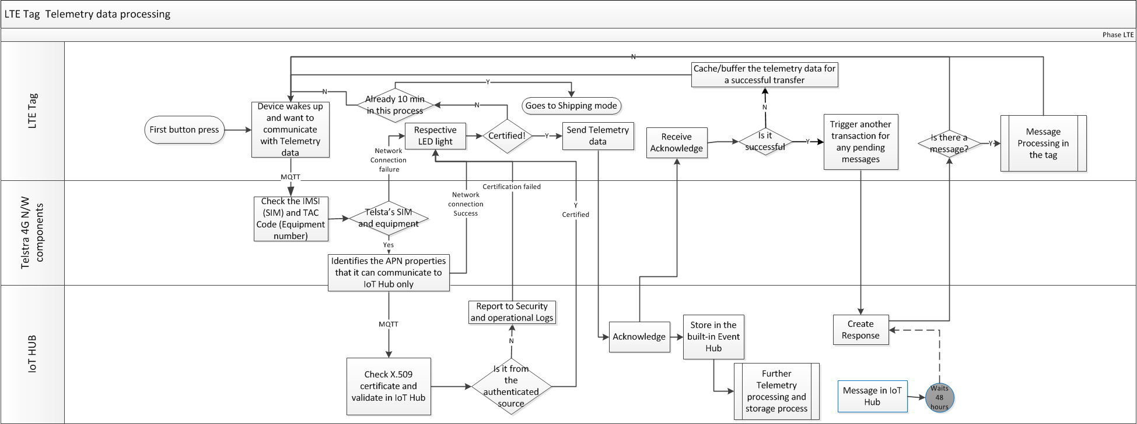

### Message processing in the tag

The following flow diagram depicts the details involved in the cloud to device message processing. 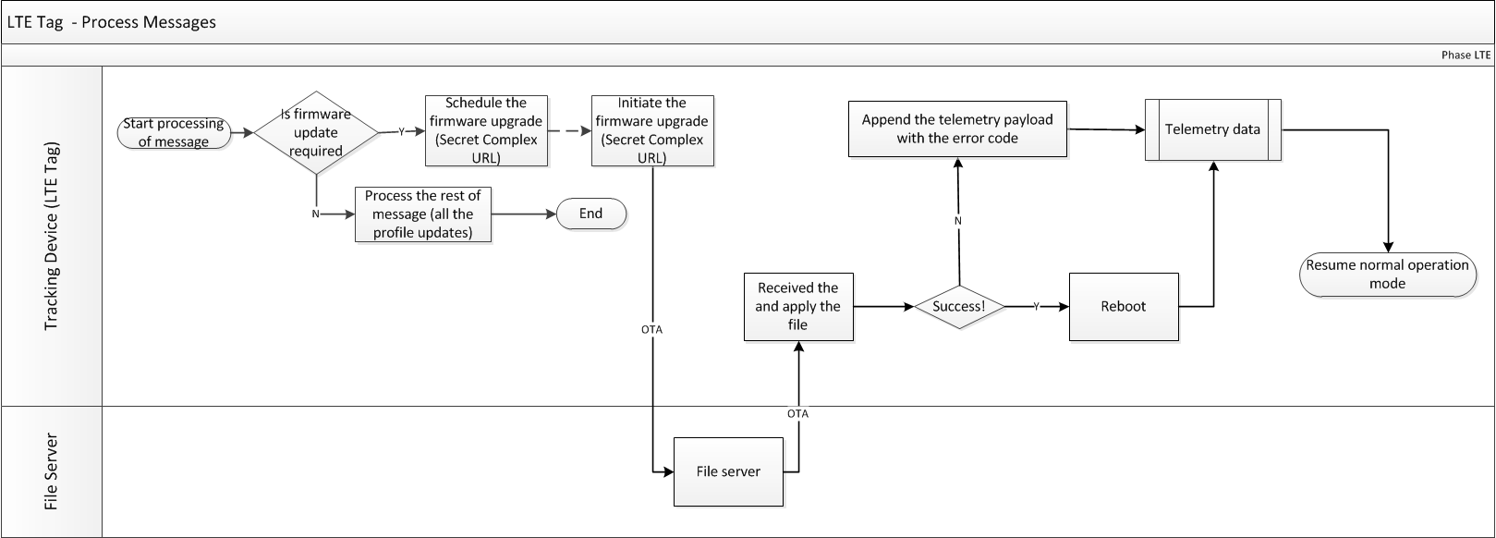

### Device Registration

The following diagram provides the details on the Bluetooth, app based flow for the device registration.

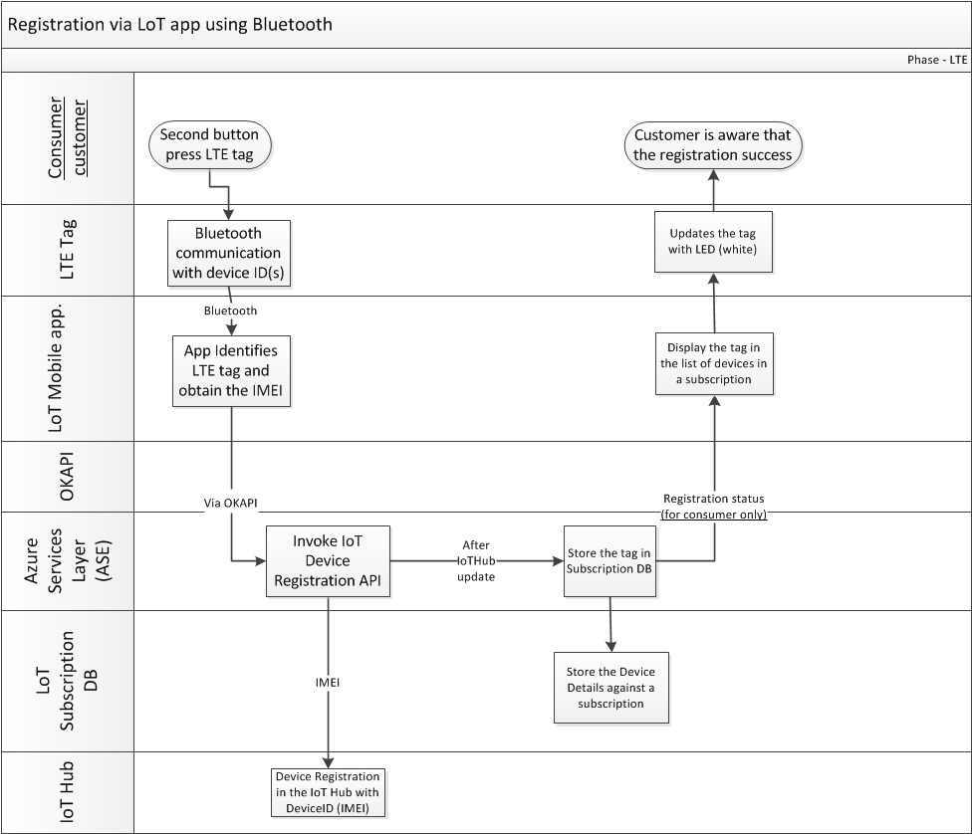

## LED Behaviour

Following is the LED behaviour at different life cycle stages and usage of the device. The below is in order of operation for the most part.

|  |  |  |  |
| --- | --- | --- | --- |
| Tag Mode | LED State | Status / Task | Detail |
| OOB Profile (out of shipping state) & Forced Diagnostics Check | RED solid | CAT-M1 Connection Issues, SIM issues |  |
| ORANGE solid | Successful CAT-M1 Connection to Network |  |
| MAGENTA solid | Successful CAT-M1 and Azure IoT Hub Connection |  |
| GREEN blinking | Searching for GPS satellites and link being established | 2 flashes every second |
| GREEN solid | Successful CAT-M1 and IoT Hub Connection along with GPS location fix |  |
| BLUE blinking | BLE advertising and waiting for BLE connection from LoT App |  |
| WHITE solid | Successfully on-boarded and profile has been provisioned onto the device | Stays solid for 15 seconds |
| In Configured mode with active Profile | RED blinking | Critical battery level, needs charging | 3 flashes every 1 minute |
| WHITE blinking | Battery charging in progress | Blinking until battery is fully charged |
| WHITE solid | Battery charging has completed | Solid until charger is removed |

## Button Behaviour

|  |  |  |
| --- | --- | --- |
| Button State | Action | Buzzer Tone |
| Pressed and released | Wake up device from Shipping State and turns on LTE radio, if pressed again it will wake up the BLE radio | Plays Beep Beep Tone |
| Held for 2 - 4 secs and released | Shows the current state of device connection via LED.  *Eg: if successfully connected the White LED will remain solid for 15 secs* | Plays Beep Beep tone |
| Held for 5 - 8 secs and released | Performs Device Diagnostics and Cycles through the LED States to determine if the device is successfully communicating to IoT Hub then sends the latest telemetry data to IoT Hub | Plays Beep Beep tone |
| Held for 9 - 11 secs and released | Soft Reboot device  *Does not factory reset or remove customer data* | Plays Beep Beep tone |

### Tracker in Shipping State

First Button press:

1. Plays Telstra Sting tone on buzzer
2. Increments button press count
3. Turns on LTE Radio
4. Start sending telemetry to platform every 1 minute.

*Platform will check whether the device is assigned to a customer account and will decide as to whether to accept or reject the payload*

1. Starts 10 minute timer

Second button press:

1. Plays beep beep tone on buzzer
2. Increments button press count
3. Turns on Bluetooth Radio
4. Turns on Bluetooth LED to blinking state
5. Starts to advertise Bluetooth packet at accelerated rate for 30 seconds at 546.25ms, then from 30-60 seconds at 1285ms, then return to 2570ms.
6. If Bluetooth connection occurs, stop LED blinking and wait for further command from App
7. App to interrogate the IMEI of the device and send to platform and link to customer account via backend

Other:

* If LTE payload receives an acknowledgement to say it was received correctly, then stop the timer and request new characteristic information from platform via MQTT
* If no successful on-boarding session has completed within 10 minutes disable all radios and go to back to sleep/shipping state
* **At any point of time, the buttons are NOT to factory reset the tracker**. Only the app (via secure BT connection) or the platform with a secure connection to the device is permitted after validating the request (user).

## Buzzer Behaviour

Plays Telstra sting when coming out of shipping state only, all future button presses are a simple beep beep sound. Refer to 4.8 for more detail.

## Battery Level Reporting

The battery level will be reported as part of the LTE payload and Bluetooth advertising packet. There are currently four levels that can be reported on, the below tables indicates how this is determined per device:

|  |  |
| --- | --- |
| Bartlett (TR100) | |
| Range | **Value** |
| 76~100% | High |
| 41~75% | Good |
| 26~40% | Low |
| 0~25% | Critical |

|  |  |
| --- | --- |
| Stone (TR300) | |
| Range | **Value** |
| 76~100% | High |
| 31~75% | Good |
| 16~30% | Low |
| 0~15% | Critical |

# Integration specifications

The below sections provide the three kinds of integration with the device and respective specifications.

Telstra’s API call to play the Telstra Sting tone on the device for a set number of revolutions.

## LTE Device from or to LoT app

The Bluetooth based communication during the registration process and any BLE parameters set through the app would be part of this interface. Bluetooth SDK is in the references sections as an attachment. The advertisement set of fields to be considered (but not limited to) are:

|  |  |  |  |
| --- | --- | --- | --- |
| Name | Start Byte:Bit | Byte:Bit  Count | Description |
| Manufacturer ID | 0x00 | 2 | Telstra’s Bluetooth manufacturer ID.  ( 0x0145 ) |
| Advert Revision | 0x02:0 | 0:5 | A number that uniquely identifies the format of the rest of the advertisement.  ( 0 ) |
| Device Type | 0x02:5 | 0:3 | A unique LoTP device type.  ( 0 for Bartlett, 1 for Stone ) |
| Bluetooth Address | 0x03 | 6 | The BA of this device. |
| Notifier | 0x09:0 | 0:1 | A value that changes to avoid iOS caching advertisements.  ( random number ) |
| Button Presses | 0x09:1 | 0:3 | Number of times the button has been pressed.  ( lifetime counter unaffected by factory reset ) |
| Battery Level | 0x09:4 | 0:4 | The battery level is detailed as per section 4.10  0 - Critical  1 - Low  2 - Good  3 - High |
| Authentication Data | 0x0A | 16 | Data used to authenticate this device as a genuine LoTP device. |

During theregistration process, the IMEI also needs to be passed to the LoTC app.

## LTE Device to IoT Hub

The following section provides the integration specifications for different interaction types between the LTE Devices (tags) to the platform.

The device to cloud (LoT Platform) interface specs are described in two major parts. The payload for each of the transactions. There are two transaction patterns established

1. Telemetry data – Device to Cloud messaging and
2. Profile parameter updates and firmware version check – (cloud to Device messaging) – The process is depicted in the section 4.6.1.

### All MQTT transaction Payloads

Following table provides the telemetry data payload.

|  |  |  |  |  |  |  |  |  |  |  |  |  |  |
| --- | --- | --- | --- | --- | --- | --- | --- | --- | --- | --- | --- | --- | --- |
| Hierarchy (Indentation ) | | | | | Item | Field | Field Type | | Example Data | | | Comments | |
| 1 |  |  |  |  | **version** | Required | Number | | 1.1 | | | Version number of the message payload - value specified by Telstra | |
| 2 |  |  |  |  | **device** | Required |  | |  | | |  | |
| 2 | **a** |  |  |  | phoneNumber | Optional | Number | | 0400123456 | | |  | |
| 2 | **b** |  |  |  | ICCID | Optional | Number | | 5555 | | |  | |
| 2 | **c** |  |  |  | IMEI | Required | Number | | 55555555555555 | | | Value to be hashed as part of Telstra’s Security Ops recommendation | |
| 2 | **d** |  |  |  | IMEISVN | Required | String | | 1.2.0 | | | Module details | |
| 2 | **e** |  |  |  | lteMac | Required | String | | 00:00:00:00:00:00 | | |  | |
| 2 | **f** |  |  |  | wifiMac | Optional | String | | 00:00:00:00:00:00 | | |  | |
| 2 | **g** |  |  |  | btMac | Optional | String | | 00:00:00:00:00:00 | | |  | |
| 2 | **h** |  |  |  | hardwareId | Required | String | | INBAR1C | | | "INBAR1C" is for Bartlett "INSTO1E" is for Stone | |
| 2 | **i** |  |  |  | fwVer | Required | String | | 1.0.0 | | |  | |
| 2 | **J** |  |  |  | DeviceProfileID | Required | String | |  | | | Need to finalise the nomenclature. | |
| 2 | **k** |  |  |  | errors | Optional | Array | |  | | | Details of each error state to be defined, and added as required. | |
| 2 | **j** | **I** |  |  | **errorCode** | Required | String | | E00m101 | | | Need to define the error code nomenclature. | |
| 3 |  |  |  |  | **rfStats** | Required |  | |  | | |  | |
| 3 | **a** |  |  |  | **Cellular** | Required |  | |  | | |  | |
| 3 | **a** | **I** |  |  | rxLevel | Required | Number | | 5 | | | Devices that support 5 bar signal strength indication should display the bars as follow: 5 bars RSRP > -90 4 bars -90 ≥ RSRP > -100 3 bars -100 ≥ RSRP > -105 2 bars -105 ≥ RSRP > -115 1 bars -115 ≥ RSRP > -120 0 bars RSRP ≤ -120 or No Sync to LTE Reference Signals | |
| 3 | **a** | **ii** |  |  | carrier | Required | String | | Telstra | | |  | |
| 3 | **a** | **iii** |  |  | connection | Required | String | | CATM1 | | | CATM1, CATNB1, CAT1, etc | |
| 3 | **b** |  |  |  | **Wi-Fi** | Optional |  | |  | | | Post MVP Requirement | |
| 3 | **b** | **i** |  |  | rxLevel | Required | Number | | 5 | | | Post MVP Requirement | |
| 3 | **b** | **ii** |  |  | ssid | Required | String | |  | | | Post MVP Requirement | |
| 4 |  |  |  |  | **Data** | Optional | Array | |  | | |  | |
| 4 | **a** |  |  |  | dateTime | Required | Date/Time | | 2018-01-01T00:00:00.000+00 | | | Date Time in ISO format (needed for clarity of records vs what the platform clock is defined as) | |
| 4 | **b** |  |  |  | **sensors** | Required |  | |  | | |  | |
| 4 | **b** | **i** |  |  | **accelerometer** | Optional |  | |  | | |  | |
| 4 | **b** | **i** | **1** |  | x | Required | Number | | 129 | | |  | |
| 4 | **b** | **i** | **2** |  | y | Required | Number | | -987 | | |  | |
| 4 | **b** | **i** | **3** |  | z | Required | Number | | 47 | | |  | |
| 4 | **b** | **ii** |  |  | **battery** | Optional |  | |  | | |  | |
| 4 | **b** | **ii** | **1** |  | low | Required | Boolean | | FALSE | | | boolean true false | |
| 4 | **b** | **ii** | **2** |  | level | Required | Number | | 70 | | | low, medium, high ( no absolute value possible as there is no fuel guage ) | |
| 4 | **b** | **ii** | **3** |  | charge | Required |  | | FALSE | | | boolean true false | |
| 4 | **b** | **ii** | **4** |  | lastCharge | Required | Number | | 500 | | | mins since last charge | |
| 4 | **b** | **iii** |  |  | **button** | Optional |  | |  | | |  | |
| 4 | **b** | **iii** | **1** |  | count | Required | Number | | 0 | | |  | |
| 4 | **b** | **iv** |  |  | **buzzer** | Optional |  | |  | | |  | |
| 4 | **b** | **iv** | **1** |  | count | Required | Number | | 0 | | | Lifetime count of buzzer plays | |
| 4 | **c** |  |  |  | **location** | Optional |  | |  | | |  | |
| 4 | **c** | **i** |  |  | latitude | Required | Number | | 33.786964 | | |  | |
| 4 | **c** | **ii** |  |  | longitude | Required | Number | | -84.38827 | | |  | |
| 4 | **c** | **iii** |  |  | altitude | Optional | Number | | 569.52 | | |  | |
| 4 | **c** | **iv** |  |  | bearing | Optional | Number | | 70 | | |  | |
| 4 | **c** | **v** |  |  | speed | Optional | Number | | 20.5 | | | speed in meters per second | |
| 4 | **c** | **vi** |  |  | accuracy | Required | Number | | 2.9 | | |  | |
| 4 | **c** | **vii** |  |  | source | Optional | String | | GPS | | |  | |
| 4 | **d** |  |  |  | **rfData** | Optional |  | |  | | |  | |
| 4 | **d** | **i** |  |  | **Cellular** | Optional |  | |  | | |  | |
| 4 | **d** | **i** | **1** |  | **attachedCell** | Optional |  | |  | | |  | |
| 4 | **d** | **i** | **1** | **A** | band | Required | String | | LTE | | |  | |
| 4 | **d** | **i** | **1** | **B** | bandNum | Required | Number | | 3 | | | Channel number | |
| 4 | **d** | **i** | **1** | **C** | cellId | Required | Number | | 0 | | | Unique identifier of the cell | |
| 4 | **d** | **i** | **1** | **D** | lac | Required | String | |  | | | Location Area code (NID for CDMA) | |
| 4 | **d** | **i** | **1** | **E** | mcc | Required | String | |  | | | Mobile Country Code | |
| 4 | **d** | **i** | **1** | **F** | mnc | Required | String | |  | | | Mobile Network Code (SID for CDMA) | |
| 4 | **d** | **i** | **1** | **G** | carrier | Required | String | |  | | |  | |
| 4 | **d** | **i** | **1** | **H** | rssi | Required | Number | | -100 | | | Radio signal strength in dBm | |
| 4 | **d** | **i** | **1** | **I** | rsrp | Required | Number | | -90 | | |  | |
| 4 | **d** | **i** | **1** | **J** | snr | Required | Number | |  | | | Signal to Noise Ratio | |
| 4 | **d** | **i** | **1** | **K** | ipAddress | Required | String | |  | | |  | |
| 4 | **d** | **i** | **2** |  | **neighborCells** | Optional | Array | |  | | |  | |
| 4 | **d** | **i** | **2** | **A** | band | Required | String | | LTE | | |  | |
| 4 | **d** | **i** | **2** | **B** | bandNum | Required | Number | | 3 | | |  | |
| 4 | **d** | **i** | **2** | **C** | cellId | Required | Number | | 0 | | |  | |
| 4 | **d** | **i** | **2** | **D** | lac | Required | String | |  | | |  | |
| 4 | **d** | **i** | **2** | **E** | mcc | Required | String | |  | | |  | |
| 4 | **d** | **i** | **2** | **F** | mnc | Required | String | |  | | |  | |
| 4 | **d** | **i** | **2** | **G** | carrier | Required | String | |  | | |  | |
| 4 | **d** | **i** | **2** | **H** | rssi | Required | Number | | -100 | | |  | |
| 4 | **d** | **i** | **2** | **I** | rsrp | Required | Number | | -90 | | |  | |
| 4 | **d** | **i** | **2** | **J** | snr | Required | Number | |  | | | Signal to Noise Ratio | |
| 4 | **d** | **i** | **2** | **K** | ipAddress | Required | String | |  | | |  | |
| Message Payload - Profile reset and/or firmware check (check post Telemetry) | | | | | | | | | | | | | |
| 1 |  | | | | Version | | | Required | |  |  | |  |
| 2 |  | | | | IMEI | | | Required | | String | 55 55555 555555 5 | |  |
| 3 |  | | | | **firmwarecheck** | | | Optional | |  |  | |  |
| 3 | a | | | | firmwarefilePath | | | Required | | String |  | |  |
| 3 | b | | | | Checksum | | | Required | | String |  | |  |
| 4 |  | | | | DeviceControlParameters | | | Optional | |  |  | |  |
| 4 | a | | | | CacheRecordCount | | | Optional | | integer |  | | no. of records to cache on the device in case there is no LTE connection available for upload at the time. |
| 4 | b | | | | RadioPriority | | | Optional | | Number |  | | WiFi/LTE |
| 4 | c | | | | TelemetryUploadFrequency | | | Optional | | integer |  | | seconds. frequency at which attempt to upload telemetry data to be performed. |
| 4 | d | | | | OnboardingWaitTimeout | | | Optional | | integer |  | | seconds. No. of seconds to wait since second button press before going back to wait state. |
| 4 | e | | | | TelemetryUploadFrequencyAfterMotionDetection | | | Optional | | integer |  | | seconds. frequency at which attempt to upload telemetry data to be performed when motion detection triggered. |
| 4 | f | | | | TelemetryUploadFrequencyOnIdle | | | Optional | | integer |  | | seconds. frequency at which attempt to upload telemetry data to be performed when not in motion. |
| 4 | g | | | | MotionSensitivity | | | Optional | | String | e.g. short range, long range | | Levels  g-force threshold. motion at which a movement is deemed to have occurred to trigger tracking. |
| 4 | h | | | | FactoryResetToDefaults | | | Optional | | Boolean |  | | Enable device to be factory reset to remove all customer data and configurations, reverting to original OOB profile/state |
| 4 | i | | | | ReturnToShippingMode | | | Optional | | Boolean |  | | Enable device to return to shipping mode, in which all the radios are disabled. (Aeroplane Mode) |
| 5 |  | | | | Environment | | | Optional | | String |  | | The IoT hub endpoint that the device should connect/send telemetry to. The URL would be sent to the device. |

|  |
| --- |
|  |

# References and Attachments

| Title | Document number/Link |
| --- | --- |
| BT Specs |  |
| Wi-Fi Specs |  |
| MQTT Specs |  |
| Bluetooth Design Guidelines for iOS | <https://developer.apple.com/hardwaredrivers/BluetoothDesignGuidelines.pdf> |

# DOCUMENT CONTROL SHEET

Who to reach out to if you have any queries, questions, changes or concerns.

| Name | Raja Ravi |
| --- | --- |
| Position | Senior Solution Architect |
| Phone | 03 8647 3572 |
| Email | [Rajasekhar.ravi@team.telstra.com](mailto:Rajasekhar.ravi@team.telstra.com) |

If you have a suggestion for improving this document, please contact the person listed above.

# Record of changes

|  |  |  |  |
| --- | --- | --- | --- |
| Issue No | Issue Date | Nature of Amendment | Author |
| 0.60 | 4th Apr 2019 | Updated several sections for completeness, added BLE default operation and connectivity details to 4.4.1 | SH |
| 0.55 | 1st Mar 2019 | Updated LTE Payload spec to adjust values and add new items | RR |
| 0.50 | 21st Dec 2018 | Modified payload for factory reset and shipping mode | SH |
| 0.45 | 20th Dec 2018 | Updated and embedded Bluetooth Specs v1.2, Added Battery Level Reporting to section 4.10, section 5.1 updated to reflect new battery levels | SH |
| 0.4 | 14th Dec 2018 | Updated the section 4.6 with multiple diagrams instead of one flow diagram. The tracking changes is on the document as it is baselined. | RR |
| 0.3 | 10th Dec 2018 | Section 4.6 changed with the internal discussions held on the MQTT communication types with the LTE tag.  Section 5.2 changed to reflect the respective documentation in line with the diagram in section 4.6. Changed the name of the section 5.2.1 | RR |
| 0.25 | 7th Dec 2018 | Numerous changes to BT Specs v1.1, LTE payload, LED Behaviours, Button Behaviours, Profile Reporting Intervals, BLE Advertising Packet Structure and Spec, Hardware ID for LTE Payload and Device Control Parameters. | SH, RR |
| 0.2 | 5th Dec 2018 | Removed the section 5.2.1 – MQTT Header.  Content added to Buzzer, Button and LED behaviours | RR |
| 0.15 | 4th Dec 2018 | Edited the document along with Scott – many changes | SH, RR |
| 0.1 | 28th Nov 2018 | Draft created | RR |

# APPENDIX – A

## LoT App Expectations to support the Device design

<To be drafted>

## LoT platform Expectations to support the Device design

The below sections provide the Telstra Risk Management Framework reference guide for evaluating the consequences, likelihood and risk ratings for identified risk(s).

### IoT Hub

<To be drafted>

### Microservice (Service Fabric)

The microservice has to pull the data from the IoT Hub’s event Hub and do the following checks before pushing them into the database.

1. Device ID and

<To be drafted further>

## Azure PaaS cloud References

1. [Set up X.509 security in your Azure IoT hub](https://docs.microsoft.com/en-us/azure/iot-hub/iot-hub-security-x509-get-started)  - Install a new Azure resource - Azure IoT hub with your credentials (Azure gives $200 USD credit). I prefer you doing the PoCs which saves us the time in integration testing.
2. [Conceptual understanding of X.509 CA certificates in the IoT industry](https://docs.microsoft.com/en-us/azure/iot-hub/iot-hub-x509ca-concept)- This link provides the documentation on the X.509 certificates.
3. Github for IoT SDK: <https://github.com/Azure/azure-iot-sdks> - it has the Azure IoT SDK for C written in ANSI C (C99).

|  |
| --- |
| This publication has been prepared and written by Telstra Corporation Limited (ABN 33 051 775 556), and is copyright. Other than for the purposes of and subject to the conditions prescribed under the Copyright Act, no part of it may in any form or by any means (electronic, mechanical, micro copying, photocopying, recording or otherwise) be reproduced, stored in a retrieval system or transmitted without prior written permission from the document controller. Product or company names are trademarks or registered trademarks of their respective holders.  Note for non-Telstra readers: The contents of this publication are subject to change without notice. All efforts have been made to ensure the accuracy of this publication. Notwithstanding, Telstra Corporation Limited does not assume responsibility for any errors nor for any consequences arising from any errors in this publication. |